C.V

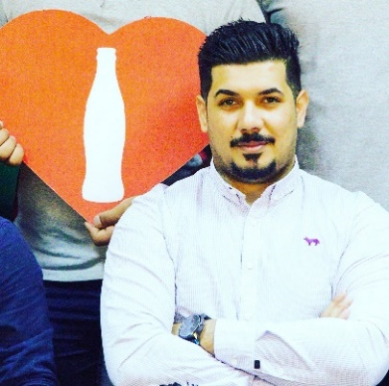

**Name**  : Hamza Mohammed Qasim

**Gender**  : Male

**Date of birth**  : 7/10/1989

**Nationality**  : Iraqi

**Address**  : Baghdad-aljehad area

**E-mail address** : hamzamohammed362@gmail.com 🖂🖳

**Mobile no** : 07707430390

* **Academic certificate**
* Institute of Technology - Department of **Electricity 2010-2011**
* **Business trainings**

|  |  |
| --- | --- |
| **Trainings** | **التدريبات** |
| **Basic Merchandising** | اساسيات الترويج |
| **Collaboration for value in Emerging Market** | معالجة الاعتراضات واسلوب العرض المقنع |
| **Basic trade math** | الرياضيات التجاريه |
| **SFE** | محللات الاداء |
| **Dealing with customer complaint** | التعامل مع شكاوي الزبائن |
| **CFV.EM (10 steps for successful call)** | الخطوات العشره للزيارة الناجحة |
| **Business Target setting** | اعداد الاهداف |
| **sales coaching** | تدريب على المبيعات |
| **EOS** | دليل استبيان نقاط |
| **Supervisor on Board** | القيادة والادارة |
| **FIT Training** | برنامج تقنية المعلومات المستقبليه |
| **OBPPC & Channel definition** | تدريب قنوات البيع ومحددات الرغبة |
| **Presentation skills** | مهارات العرض الفعال |

* **Previous positions:**
* Group of AL Tawan company, Gaulgises 2013 – 2014 as sales representative and sales supervisor backup
* Coca Cola Icecek 2014 – 2018

As sales representative (2014 – 2016) 2 years’ experience

As sales developer ( 2016 – 2017 ) 1 year experience

As Area sales manager (2017 – 2018) 2 years’ experience

**Business brief**

* Manage sales team supervisors 3 , sales representatives 23 seller
* Set monthly targets for the team
* Set market execution inside outlets
* Manage the daily sales process
* Manage daily warehouses products orders to provide stock
* Manage all Distributor problems, request, compensation with related depts.
* Coach team and provide feedback in field.
* Increase to customers and keep, maintained our relationship with existence one.